Declare a variable name ‘x’ and value ‘Hello world’, print it

Workshop #2
Flutter Developer Bootcamp

Purpose
This workshop demonstrates likely to introduce participants to the Dart programming language, focusing on its syntax, basic operations, and running simple programs.

Problem
In the given workshop demonstrates a simple program where the main function serves as the entry point. Within main, a variable x is declared and initialized with the string 'Hello world' using the var keyword. The print function then outputs the value of x to the console. This example introduces basic Dart concepts such as function definition, variable declaration, and console output, providing a foundation for beginners to learn Dart programming.

How to Solve
- Checkout the workshop from Git Repo:
git clone -b <user-branch> <repo-URL>
- Open the root folder inside VS Code
- Open the root folder in terminal
- Run the command dart run filename.dart
- Variable Declaration: Uses var for type inference (var x = 'Hello world';).
- String Handling: Assigns 'Hello world' to variable x.
- Console Output: Uses print(x); to display 'Hello world' to the console.
- Go To File: <specific-file--method> à <method-name>, implement your logic.

You will Achieve
When you complete this workshop you will learn the following:
Methods and Functions Included:

- main Function:
- void main(List<String> args)
- Entry point of the Dart program where execution starts. Can accept command-line arguments (args) if provided.
- print Function:
- print('Hello world');
- Outputs the specified message or variable content to the console.

Screenshots

Before implementation (without printing hello world)

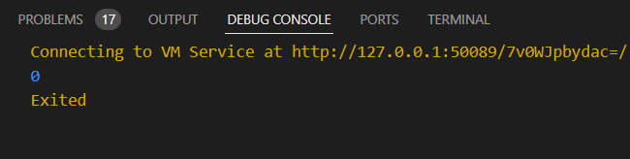

After implementation ( declare a variable x and printing hello world)

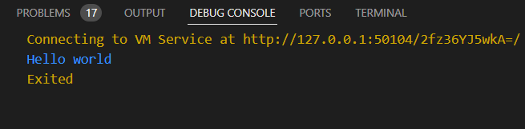

How to submit your workshop
Push your project back to the same git branch using command:
<command name>

Happy Coding!

